Life Unlimited Enabling Good Lives (EGL) Evaluation

Summary Report

Prepared by:
Dr Carey-Ann Morrison
Imagine Better Ltd

16 September 2021

Contents

Introduction 3
Background 3
Summary of process 4
Methodology 5
Number of people surveyed and interviewed 5
Demographics for face-to-face interviews 6
Research Team 7
Service Users’ Perspectives 8
Hearing Therapy 8
Altogether Autism 11
Community 14
Mobility Centres 16
Staff Perspectives 19
Hearing Therapy, Altogether Autism and Community 19
Mobility Centre 20
Staff perspectives on how well they are supported to work in EGL ways 21
Summary comparison of service user and staff perception 23
Recommendations 25
Appendix 1: EGL indicators 26
Appendix 2: Workshop activity- identifying EGL practice 36

Introduction

Life Unlimited secured funding from the Lotteries Commission to complete an evaluation of some of their services. The purpose of the evaluation was to use the EGL vision and principles to assess current practice, improve services and plan for future service delivery. Imagine Better was contracted to undertake the evaluation.
This report provides a summary of findings and offers some recommendations for next steps. It summarises responses from service users and staff, and highlights areas of strength as well as areas for improvement. It is intended to help Life Unlimited deepen their understanding of how the EGL vision and principles can be applied to their work.
The report proceeds as follows. First, it provides background information on the evaluation. Second, the methodology is described, including information on participants and response rates. Third, the perspectives of service users are provided in the order of Hearing Therapy, Altogether Autism, Community, and Mobility Centre. Fourth, staff perspectives from each service are detailed. Fifth, service users and staff perspectives are compared. The report concludes by offering some recommendations for next steps.

Background

In May 2021, service managers and some front-line staff from Hearing Therapy, Altogether Autism, Community, and Mobility Centre, as well as some members of the Disability Leadership Group, came together with staff from Imagine Better for a one-day workshop. The aim of the workshop was to think about what good practice would look like if the EGL vision and principles were being implemented across Life Unlimited services.
From the workshop, a series of ‘EGL indicators’ were created. The EGL indicators are clues as to whether or not EGL is happening in practice. The EGL indicators are markers of what Life Unlimited want to see as part of good practice and are directly related to the eight EGL principles. The EGL indicators formed the basis for surveys and interviews with staff and service users to test whether aspects of their services they hope to see are happening.

Summary of process

Methodology

Imagine Better used the EGL indicators developed at the workshop to prepare the surveys and interview schedules. Draft versions were sent to Life Unlimited Chief Executive and service managers for review and input. Once final versions of the surveys and interview schedules were agreed, Imagine Better worked with Life Unlimited communications team to set up and distribute surveys through Survey Monkey.
One survey was created for service users who access Hearing Therapy and Altogether Autism, and another survey was created for people who use Mobility Centre. We focused on capturing recent experience and sent the survey to people who had used Life Unlimited services within the last year.
Two staff surveys were created. Service managers were asked to send the survey link to staff encouraging them to complete the survey. One survey was distributed to staff working across Hearing Therapy, Altogether Autism, and Community, and the other survey sent to Mobility Centre staff. Service managers were not specifically asked to complete the survey as they participated in the initial workshop. Their perspectives on what constitutes good EGL practice are captured in the development of the EGL indicators.
Face-to-face interviews were carried out with some people who use Hearing Therapy, Altogether Autism, and Community. Service managers were asked to work with their teams to randomly select five people to participate. Some services more easily recruited people to participate than others.
Interviews happened in person as well as over zoom. Interviews were used to gain a deeper understanding of people’s experiences of using Life Unlimited. The interview schedule and format used during face-to-face interviews was similar to the survey. The EGL indicators were used as prompts to initiate conversation. For people who use Community, they were also asked to rate their experience on the scale ‘No/Never’ through to ‘Yes/Totally’
Imagine Better hold a strong belief that ethical matters are integral to research and evaluation practice and that due attention to these issues enriches practice. All stages of evaluation were conducted in an ethical manner. The privacy and confidentiality of all those who agreed to participate was ensured. Informed consent was sought, and all participants were made to feel safe and confident to share their experiences and information. People who were interviewed were given a $50 koha to thank them for their time and contribution.

Number of people surveyed and interviewed

Overall, there was a relatively low response to the surveys, both by service users and staff. However, the low response does not undermine the value or usefulness of findings presented in this report. A qualitative assessment of Hearing Therapy, Altogether Autism, Community and Mobility Centre was undertaken, and findings are not meant to be representative. Instead, findings highlight the experiences and perspectives of a small group of service users and staff and can be used as a starting point to think about how to grow engagement in the future.

 | Number of people using and working at the service | Number of people sent survey | Number of survey responses | Response rate % | Number of people interviewed
Altogether Autism
Service Users | 3500 | 1151 | 57 | 5 | 4
Staff | 5 | 5 | 3 | 60
Hearing Therapy
Service Users | 4000 | 800 | 53 | 7 | 5
Staff | 24 | 24 | 6 | 25
Community
Service Users | 100 |  |  |  | 5
Staff | 7 | 7 | 4 | 57
Mobility Centre
Service Users | 1000(s) | 5,533 | 120 | 2
Staff | 25 | 25 | 6 | 24

Demographics for face-to-face interviews

 | Type of Interview | Age | Gender | Ethnicity | Region
Altogether Autism
 | 4 x zoom | 50  57  34(child 5)  29(child 9) | 4 x Woman | 1 x NZ European  1 x Māori  1 x Pasifika  1 x Māori/ NZ European | 3 x Bay of Plenty  1 x Wellington
Hearing Therapy
 | 1 x Zoom  4 x In-person | 60  89(child 19)  77  18 | 3 x Woman  2 x Man | 4 x NZ European  1 x Māori | 5 x Waikato
Community
 | 4 x In-person  1 x Phone | 20  34  19  45  58(child 19) | 3 x Woman  1 x Man | 1 x NZ European  4 x Māori | 5 x Waikato

Research Team

Dr Carey-Ann Morrison, Imagine Better Senior Researcher was project lead. Carey-Ann has overseen the development of the project, including developing the EGL learning resource, co-facilitating the workshop, creating the evaluation tools, analysis and writing the final report. Carey-Ann is a parent to a young disabled son. Imagine Better CEO Tony Paine co-facilitated the workshops and helped develop the evaluation tools and final report. Tony is the parent of a young disabled woman. Angela Desmarais, Researcher for Disabled Persons Assembly was subcontracted to help facilitate the workshop, and engage directly with service users, especially for the face-to-face interviewers. Angela has lived experience of disability.

Service Users’ Perspectives

Hearing Therapy

As part of the survey results, an average of 89 percent of people ranked Hearing Therapy at ‘mostly’ and ‘yes/totally’ when asked whether their experience of using the service aligned with each EGL principle.
Please note that ‘Not Applicable’ responses are excluded from these percentages.
EGL Principle | Overall percentage of ‘mostly’ & ‘yes/totally’
Self-determination |  | 90%
Beginning early |  | 89%
Person centred |  | 90%
Ordinary life outcomes |  | 82%
Mainstream first |  | 93%
Mana enhancing |  | 93%
Easy to use |  | 95%
Relationship building |  | 80%

Areas where people ranked Hearing Therapy particularly highly include:
- EGL principle ‘self-determination’ – 92% of people felt Hearing Therapy made it easy for them to ask any questions
- EGL principle ‘person centred’ – 90% of people felt Hearing Therapy listened carefully to them
- EGL principle ‘person centred’ – 90% of people felt Hearing Therapy treated them as an individual with unique needs and personal preferences
- EGL principle ‘mainstream first’ – 94% of people felt Hearing Therapy was accessible and that there were no access barriers that made it hard for them to use the service
- EGL principle ‘mana enhancing’ – 96% of people felt that Hearing Therapy staff were friendly and made them feel comfortable
- EGL principle ‘easy to use’ – 94% of people felt that Hearing Therapy gave them information in a way that was easy to understand
Included in the survey, was space for people to provide further comments about the service. The relevant EGL principles are listed under each quote.
I really appreciated the information given to me from [name] to help me make decisions that not only reassured me but empowered me to regain a positive self-image and self-manage my life. My self-esteem was in a space I had never encountered ever, and I began to question my self-worth in my new place of employment. I count it a blessing that Life Unlimited, [name] supported me with advice, came to my workplace to educate my work colleagues about my hearing disability. This lifted me to a new level as a person and encouraged me to practice self-talk to perform to my capabilities, to the standard that I knew. [Name] has left the door open for me to contact her at any time I have need to.
EGL principles – ‘mana enhancing’, ‘ordinary life outcomes’, ‘beginning early’, ‘person-centred’, ‘easy to use’, ‘relationship building’
I was really grateful to be put in touch with an organisation which could give me accurate information and clear friendly helpful advice while making it clear that what decisions I made as a result were up to me, and I really appreciated that. My hearing therapist was relaxed, intelligent and sensitive in her manner, listened carefully and acknowledged my opinions, and I enjoyed meeting her. Many thanks for the help.
EGL principles – ‘self-determination’, ‘mana enhancing’, ‘relationship building’, ‘person-centred’
This is a fabulous service providing sound and accurate information and advice. My husband and I really benefited from hearing testing and receiving good ideas to aid hearing in our day to day lives. The appointment was handled really well and we were able to be tested together and so were aware of each other’s results. Thank you very much!
EGL principles – ‘easy to use’, ‘beginning early’, ‘relationship building’
Conversations during face-to-face interviews echoed the survey results. In relation to the EGL principles ‘self-determination’ and ‘easy to use’, people spoke about Hearing Therapy staff using a range of techniques to ensure that they understood the information they were being given. During face-to-face interaction, staff would often repeat information back to people to make sure they understood correctly, as well as putting information in a follow up email so people could refer to anything they may have missed.
They looked at my face on so I could lip read. It wasn’t echoey in the room, it was good. If they rang me and I couldn’t them properly, they’d write up a follow up email with everything I needed to know.
People spoke of receiving an individualised service from Hearing Therapy, aligning with the EGL principle ‘person centred’. They described being treated as a unique individual and receiving services that were tailored to their specific needs and personal circumstances.
They treat me as an individual, not as a number. Other places you feel like you are a number. It’s a personal thing.
Having enough time during appointments was described as an important part of receiving an individualised service. People didn’t want to feel rushed. Everyone who was interviewed spoke about having ample time with Hearing Therapy staff. This is important because it meant people felt that the time was taken to get to know them, and they were able to ask questions.
Didn’t feel rushed – not at all. There was always time. She’d always ask if we had any more questions or if there was anything she could help with. She gave us her email and said to get in touch if there were any questions afterwards.
Many people commented that they felt as though Hearing Therapy staff respected them and their own ability to make choices about things that were right for them. It was emphasised that at no time, did they feel ‘pushed’ into anything. These conversations demonstrate the EGL principle ‘mana enhancing’.
My daughter was respected. Just being heard is a sign of respect. Listening to [my daughter]’s story and how frustrated she was …. She left [the appointment] excited because she felt heard – not pushed aside. There was sympathy and compassion.
Some people talked about having improved life outcomes as a result of using the Hearing Therapy, for example, increased confidence and inclusion in social settings, aligning with the EGL principle ‘ordinary life outcomes’.
[Daughter]’s work life has changed immensely. She has more confidence, even socially she has more confidence.
One person referred to a hearing therapist having a partner with similar hearing issues, so they felt they understood what they were going through:
The hearing therapist has a family member with hearing loss and other hearing issues. I had the same hearing issues and she understood that. It’s always nice to know someone understands what you have experienced. I trusted her.
Some people talked about aspects of Hearing Therapy service that could be improved, as demonstrated in the quotes from the survey and interviews below:
It’s not always easy to access because I feel they are horribly understaffed.
There’s a lack of staff. Not that easy to get an appointment. You have clients waiting.
While I was talking to Life Unlimited staff, she was typing constantly and not really listening attentively. All she recommended was that I should just wear my hearing aid more. It was a waste of time as I felt that she didn't really listen to what I was really saying to her, and she gave me a pretty standard answer. I don't even know what her purpose was really. She had a cheesy smile and was all nice, but it was just on the surface.

Altogether Autism

As part of the survey results, an average of 59 percent of people ranked Altogether Autism at ‘mostly’ and ‘yes/totally’ when asked whether their experience of using the service aligned with each EGL principle. For several of the questions, there was a high number of people who selected the ‘Not Applicable’ option.
Please note that ‘Not Applicable’ responses are excluded from these percentages.
EGL Principle | Overall percentage of ‘mostly’ & ‘yes/totally’
Self-determination | 54%
Beginning early | 53%
Person centred | 78%
Ordinary life outcomes | 50%
Mainstream first | 59%
Mana enhancing | 66%
Easy to use | 64%
Relationship building | 50%

Areas where Altogether Autism were ranked particularly well include:
- EGL principle ‘self-determination’ – 65% of people felt Altogether Autism made it easy for them to ask questions
- EGL principle ‘mana enhancing’ – 79% of people felt Altogether Autism respected and trusted them
- EGL principle ‘mana enhancing’ – 84% of people felt Altogether Austin respected their culture/spirituality/beliefs
- EGL principle ‘mana enhancing’ – 74% of people felt Altogether Autism staff were friendly and made them feel comfortable
- EGL principle ‘easy to use’ – 67% of people felt Altogether Autism gave them information in way that they could easily understand and use
- EGL principle ‘easy to use’ – 71% of people felt they could easily get in touch with Altogether Autism
Included in the survey, was space for people to provide further comments about the service. The relevant EGL principles are listed under each quote.
I really appreciate the weekly Zoom Hui (by autistics for autistic adults). It is helping me learn to stick in there and keep trying to be social, because I have a long history of isolating and avoiding social contact. The Christmas gift last year was very special too - thank you for that. I also liked the Autism Acceptance Month Facebook 'take-over' posts by autistics and their family members - it was clear from the tone of the posts that Altogether Autism is a service that autistic people can trust. Thank you.
EGL principles – ‘relationship building’, ‘ordinary life outcomes’, ‘person-centred’, ‘mana enhancing’
I have found the Altogether Autism newsletter to be very positive and uplifting as well as informative. I hope that this publication can be continued. Thank you for all the amazing work you do. I enjoyed meeting other parents at the coffee group and listening to the inspiring speakers that came along.
EGL principles – ‘relationship building’
I only had one interaction, by email, asking for general information about Autism. I got a fast response with information I was looking for. I didn’t need any more interactions. Thanks
EGL principles – ‘easy to use’
Great service - any information requested was delivered within super quick timeframes, was thorough and was trustworthy/as evidenced-based as possible.
EGL principles – ‘beginning early’
During the face-to-face interview, people spoke about the information that they received from Altogether Autism as being comprehensive and including links and references, relating to the EGL principles ‘self-determination’ and ‘easy to use’. These people also acknowledged that it was useful having information in an email to refer to when needed.
Their research service is for if there’s anything you want to know about Autism, they have got access to journals and websites that I don’t have access to. I had a question I couldn’t answer from publicly available information and their researcher did an amazing job flushing out research for me and summarising it in an understandable way with all the research links. It was a stunning service, which I am now using again. She wrote a report that put the research into English in an understandable way but with references. I was really impressed, and it was superfast, way faster than I expected.
The lady sent me an email with links and reports and different information to see what could help me, e.g. Parent to Parent or if I needed a disability allowance or how to navigate Ministry of Education website. All of that was really helpful. When you are new to Autism or neurodiversity it can be overwhelming to have a lot of information given to you in folder form. Whereas if it’s set out in an email, this can be useful.
In relation to EGL principle, ‘easy to use’, some of the people we spoke to accessed Altogether Autism through the chat function. One person mentioned that written communication was much easier, and this chat function was a great tool. Another person commented on the seamless delivery of services meaning she did not need to spend significant amount of time organising things.
As soon as you log in to the website it pops up. They get back to you pretty quickly. They can direct you to whatever supports you are needed.
I signed up for their journal and I got a whole lot more. The local coordinator contacted me and then connected me with someone in the community. She sent me a flier for a local support group meeting and told me about the Zoom meetings.
Having somebody local to meet within this community was highly valued by all the people we spoke to. This included the whānau of Autistic people and aligns with the EGL principle ‘ordinary life outcomes’.
I left the house and met someone in the community. I’m going to get emotional talking about this. I haven’t done that in over 4 years. That’s a pretty profound outcome that I was able to achieve that, going out into the community, and that’s because of that support from the local coordinator.
The value of having Altogether Autism facilitate connections between people with similar experiences was discussed, in line with the EGL principle ‘relationship building’.
The different workshops and information they provide have opened me up to a wider support network – predominantly mothers – in the community. They know what you are going through or walked a similar path.
I have been able to build some good friendships with other mums of Autistic children.
Some people talked about aspects of Altogether Autism service that could be improved or areas they were dis-satisfied with, as demonstrated in the quotes from the survey and interviews below:
I was looking for Māori cultural expertise and the response was very generic. I’m not bothered ‘cos I know how rare it is to find I was just having a go and hoping for the best…it’s been difficult to get this specific Māori support.
I was very disappointed with the change to service around requesting information. In the past, a comprehensive response was received and was always very relevant but now I get a list of website to go and look up for yourself, I could have done that myself and not have to have waited.
I would really like to see something for the kids, whether it’s a separate webpage or a journal like they have, to get the kids involved, like competitions, catered to autistic kids, profiles about Autistic children around NZ and what they are getting up to.
I felt that Altogether Autism treated my request for support with disregard, contacting the organisation 4 times by phone over as many weeks, without response from the local representative. Following my second complaint, I was finally contacted and there was little connection with the individual and little or no help or advise, simply being referred onto another organisation. I found that there was little understanding of my needs as a high functioning Autistic adult, or interest in supporting them. I was informed that the focus of the service was Parent to Parent and that there was little that could be done to support me. Altogether Autism was my last option to get some help with the crisis situation in my life, and I feel that, like many other adult autistics that we just do not matter, as the focus is on the young and their needs.
The resources are probably underutilised – there are probably a lot of Pasifika parents who need help like my son but find it overwhelming. What I know about Pasifika is that it’s hard in spaces they are not familiar with. Perhaps information evenings in places with a big Pasifika presence, it may be helpful for people who find coming forward challenging.
While everyone had good intentions there was very little provided to support our family with our son's diagnosis. The most I recall is an email with a list of books I could maybe access but was too difficult to do. I met with a support group once but it was only really social. There has been no individual discussions about our individual situation and no individual recommendations. Most of our questions and requests are responded with "I don't know, I will check" or "the system is under-resourced so you're not alone".
People were asked to specify their main method of contacting Altogether Autism with results shown in the table below:
Contact Method | Response rate
Altogether Autism website | 70%
By phone | 11%
Social Media e.g. Facebook, Instagram, Twitter, Google | 14%
Live Chat | 9%
Walk in to Parent to Parent offices (National or regional) | 2%
Walk in to Life Unlimited | 0%
Can't remember | 9%
Other (please specify) | 14%

Community

Five face-to-face interviews happened with people who use Community. Participants worked through the interview schedule with the researcher. For each EGL indicator, people were asked to rank their experience on a scale of ‘No/never’ through to ‘yes/totally’. Visual icons – a smiley/sad emoji and thumbs up/down - were used to help assist people to make their decision. Some people indicated their position by ticking the box themselves, others pointed to their rating and the researcher filled it in for them. Some people gave detailed examples of their experiences that related to their rating and the researcher typed this information in to the interview schedule. Most people ranked Community at ‘mostly’ and ‘yes/totally’ for each EGL principle.
Relationships with staff were discussed as part of nearly every EGL principle, highlighting the centrality of this relationship to people’s experiences of Life Unlimited Community. People mostly spoke positively about their interactions with Life Unlimited staff. For some people, this relationship gave them the confidence to try new things and helped them feel comfortable in new situations, aligning with the EGL principles ‘ordinary life outcomes’ and ‘beginning early’. When asked about whether the support they receive from Life Unlimited makes a positive different in my life, one person said:
Yes, definitely it’s been a change in my life of course. They give me options, advice, a new mindset. They figure out a new mindset for me mentally and physically. They make sure that I am comfortable, and they are not rushing things.
I am supported by Life Unlimited to try new things
People talked about feeling ‘at home’ with staff, with one person describing staff as ‘like family’. Another person referred to speaking to and joking with ‘the big boss’ which helped increase this person’s sense of mana, related to EGL principles ‘mana enhancing’ and ‘easy to use’.
In relation to EGL principle ‘person centred’, everyone described having enough time with Life Unlimited staff to ask questions and make choices.
Whenever I suggest something they are just there to listen and have patience. Not rushed.
No no no rushed. We stick together with my friends and staff. No hurry
Some of the participants talked about doing fun activities, like colouring, cooking, and playing sport. It was not clear whether people were making choices from a set of predetermined options or whether these were the choices they made themselves and were supported to pursue. Nevertheless, in line with EGL principle ‘person centred’, ‘ordinary life outcomes’, ‘self determination’, people enjoyed having a range of options to choose from:
Definitely. I am hoping to dig in to jewellery making. With those kinds of materials. They’ve got programs which is brilliant so at least you can go outside of that class and go into the classes that you want to do.
I’m good at sports. I like basketball. We play basketball. I no win yet. I do cooking Tuesdays. I like cooking.
One person made the comment that staff sometimes make decisions about the activities they do:
Definitely activities. They help my staff to support me. The staff make a decision sometimes for us which is okay but sometimes not.
There was a strong sense from people that they felt their cultural and/or spiritual beliefs were respected by Life Unlimited, related to EGL principle ‘mana enhancing’ and ‘relationship building’. Some of the activities they spoke about were connected to cultural events, for example, Matariki.
They just respect my hapu and my whakpapa and the whole cultural thing.
They follow tikanga.
When asked questions about engaging with community and mainstream activities, in relation to the EGL principle ‘mainstream first’, people described taking part in mainstream activities. However, as conversations progressed, it appeared that in most cases they were taking part in activities available in the community that were created for and used by disabled people – both connected to Life Unlimited as well as other disability support providers. The issue of confidentiality and boundaries with support workers was raised and the challenges of raising these issues with Life Unlimited, related to EGL principle ‘mana enhancing’.

Mobility Centres

As part of the survey results, an average of 86 percent of people ranked Mobility Centre at ‘mostly’ and ‘yes/totally’ when asked whether their experience of using the service aligned with each EGL principle. For several of the questions, there was a high number of people who selected the ‘Not Applicable’ option.
Please note that ‘Not Applicable’ responses are excluded from these percentages.
EGL Principle | Overall percentage of ‘mostly’ & ‘yes/totally’
Self-determination | 89%
Beginning early | 87%
Person centred | 80%
Ordinary life outcomes | 86%
Mainstream first | 86%
Mana enhancing | 87%
Easy to use | 93%
Relationship building | 78%

Areas where Mobility Centre were ranked particularly well include:
- EGL principle ‘self-determination’ – 91% of people felt Mobility Centre staff actively listened to their requirements and asked questions
- EGL principle ‘beginning early’ – 87% of people felt Mobily Centre got back to them quickly if they ever contacted them
- EGL principle ‘mainstream first’ – 90% of people felt the Mobility Centre online store was easy to use
- EGL principle ‘easy to use’ – 93% of people felt they were given information in a format they needed and a way they could understand, including information that was on the internet
Included in the survey, was space for people to provide further comments about the service. The relevant EGL principles are listed under each quote.
Mobility Centre are very prompt with their internet services and dispatch. They have contacted me when there has been an issue or alteration with my order and I have been happy with their response.
EGL principles – ‘beginning early’, ‘person-centred’
I used your online service which I found really easy to use. The turnaround was immediate, and the products purchased were amazing. I was bed bound post-surgery for a bit and the ability to give myself a "bed wash" that made me feel clean and fresh was superb. A little went a long way into my inpatient stay and allowed me to maintain a little independence.
EGL principles – ‘easy-to-use’, ‘ordinary life outcomes’, ‘mana enhancing’
I must emphasise the knowledgeable staff at the Hamilton Mobility center.
EGL principles – ‘self-determination’
They were able to recommend products more suitable. They are just so helpful and friendly it really makes a difference. Thankyou
EGL principles – ‘self-determination’, ’mana enhancing’, ‘person centred’
The Lower Hutt store is so much better than it used to be. The staff and layout of the shop are welcoming, and it is a pleasure to shop there.
EGL principles – ’mana enhancing’, ‘mainstream first’
Some people talked about aspects of Mobility Centre that could be improved or areas they were dis-satisfied with, as demonstrated in the quotes from the survey below:
There is nothing specific I can identify, but when I / we go into the shop, I usually feel I’m interrupting something more important (than me / us) ... another customer, a phone call, paperwork ... it’s nice not to deal with an aggressive sales pitch, but sometimes it’s been borderline ignore and make your own mind up. Havent been in for a while now, but i recall my most recent visit was more pleasant and helpful.
Well yes I have to say one thing and that is on entering the store I am often confronted by a lady who is obviously part owner of the firm and I would rather go elsewhere than front to this lady, she is lovely a probably doesn’t realise that it’s not possible to deal with her without having to buy something. This is not good for business.
contacted mobility center online regarding a home visit to discuss mobility scooter for my mother....over 2 months ago...NEVER HEARD BACK! Not impressed, I am a Nurse and always contact my patients. Be interesting if I hear back after this......
Products on your website need updated as soon as they become out of stock.
Your products a way to expensive. Cheaper by thousands of miles on Trademe
People were asked to provide detail on their disability status. They were asked to select as many options as were applicable to their situation with results shown in the table below:
Disability status | Percentage of service users
No disability or access needs | 22%
Have a permanent disability impacting on accessibility | 27%
Have a temporary disability/injury rehabilitation | 15%
Have age related mobility restrictions | 30%
Am a family member of someone with a disability or support someone with a disability | 24%
Total Respondents | 117

Staff Perspectives

The second phase in the project – where Life Unlimited staff worked with Imagine Better to develop indicators of good EGL practice – was an important data gathering activity. The workshop was led by the knowledge and experience of Life Unlimited staff about what they value as good EGL practice. Staff identified areas of priority and labelled practices as key examples of good EGL practice. They also identified things that they specifically wouldn’t want to see. This exercise was crucial for establishing performance expectations about what good service looks like from the perspective of staff as well as the perspective of service users.

Hearing Therapy, Altogether Autism and Community

As part of the online survey, staff from Community, Altogether Autism and Hearing Therapy were asked to complete three tasks:
- consider each EGL principle and provide some examples of where and how they see the indicators in action. If they couldn’t think of any examples, they were asked to specify what needed to happen/change to make this possible.
- Make an overall assessment of how well Life Unlimited is putting each EGL principle into action.
- Give an assessment of how well the organisation is doing supporting them as a staff member to work in EGL ways
Staff were asked to rate the level at which they thought the organisation’s work aligns with each EGL principle. Most staff believe that the work Life Unlimited does is consistent with each of the EGL principles, with an average of 90 percent choosing ‘mostly’ and ‘yes/totally’ when rating the organisation’s work against each principle.
While staff mostly felt EGL was visible across their work when it came to rating the organisation, there was varying level of detail provided in the written examples. Some EGL principles were responded to in more detail than others. Often sections were left blank, or answers were repeated for different questions. The table below summarises the types of examples of EGL practice staff provided in the staff survey:
Hearing therapy | EGL principles ‘self determination’, ‘person centred’, ‘beginning early’  listening closely to people and allowing their situation and needs to drive the conversation and development of support plans.  EGL principles ‘self determination’, ‘person centred’, ‘easy to use’  flexible and individualised approach to supporting people through different communication styles and appointment formats e.g face-to-face, email, meeting at home.  EGL principle – ‘relationship building’, ‘mainstream first’  recognize people are part of families and communities e.g encourage families to attend hearing assessments, providing culturally appropriate services in culturally appropriate spaces.
Altogether Autism | EGL principle ‘mana enhancing’  the importance of disabled leadership, lived experience and autistic expertise  EGL principle ‘mainstream first’, ‘ordinary life outcomes’, ‘mana enhancing’  understanding the need for a ‘twin- track’ approach to supporting autistic people to access both ‘autistic space and services’ and ‘mainstream spaces and services’  EGL principles ‘easy to use, ‘self-determination’  choice and control over engaging with the service e.g live chat, phone calls, emails, Autistic Zoom hui  EGL principles ‘mainstream first’, ‘ordinary life outcomes’  advocacy and tools to help make communities more welcoming and inclusive of autistic people.
Community | EGL principles ‘self determination’, ‘person centred’, ‘mana enhancing’  treating everyone as individuals and responding to people’s unique needs e.g. tailoring communication style, information and advice.  EGL principles ‘relationship building’  focus on supporting people and their families/communities by listening and building trust with people.

Mobility Centre

Mobility Centre staff were asked as part of a survey to complete two tasks:
- Provide an assessment of how well they think they are doing putting the EGL vision and principles into action
- Give an assessment of how well the organisation is doing supporting them as a staff member to work in EGL ways.
The following table is taken from the survey with Mobility Centre staff and shows how well staff think they are doing putting the EGL vision and principles into action:

EGL Indicator | Overall percentage of 'mostly' & 'yes/totally'
We actively listen to people and facilitate their involvement in decision-making about what products and services they require. | 83%
We make it easy for people to ask questions about our products and services and take the time to listen and respond. | 100%
We provide people with a range of options based on what they tell us they need and want. | 100%
We provide information about our service and products in a range of accessible formats. | 50%
We ensure the layout of our store is easy to move around and products are easy to find. | 67%
Our online store is easy to use and people can easily find the information they are looking for. | 50%
We respond quickly to queries about our services/products and requests for information. | 67%
We treat people as unique individuals with specific needs and personal preferences – we don’t make assumptions based on their impairment. | 100%
We have good knowledge about other supports/services in the community and where appropriate share this with people. | 50%
We ensure opportunities for people to provide feedback about our products and services. | 33%
We involve disabled staff and disabled people in the design, delivery, and evaluation of our stores | 50%
We get back to people when we say we will. | 50%

Staff perspectives on how well they are supported to work in EGL ways

The following table provides an overall assessment of how well staff think Life Unlimited is doing supporting staff to work in EGL ways. It combines staff responses from Community, Hearing Therapy, Altogether Autism and Mobility Centres.

EGL Indicator | Overall percentage of 'mostly' & 'yes/totally'
Life Unlimited’s commitment to EGL is clear and represented in our vision and values. | 83%
I have access to training and resources about the EGL principles and vision. | 78%
I have access to the resources to produce information in a variety of communication methods (NZSL, braille, easy-read, core-board). | 39%
Life Unlimited encourages staff to suggest new ways to implement the EGL principles. | 78%
New staff learn about the EGL principles. | 61%
Staff have enough time to spend getting to know the people we support. | 89%
Life Unlimited has an active programme in place recruiting and supporting disabled people in our workplaces | 72%
I can see EGL reflected in our policies and procedures. | 83%
My team has regular opportunities to reflect on our work and talk about EGL practice. | 61%
My team has a focus on ways that we can ensure our services are tailor-made to individuals and don’t take a ‘one size fits all’ approach. | 78%
Life Unlimited operates according to a facilitation-based approach | 72%

Summary comparison of service user and staff perception

Hearing Therapy
EGL Principles | Overall percentage of 'mostly' & 'yes/totally'
 | Staff | Service Users
Self-determination | 100% | 90%
Beginning early | 100% | 89%
Person centred | 100% | 90%
Ordinary life outcomes | 100% | 82%
Mainstream first | 100% | 93%
Mana enhancing | 100% | 93%
Easy to use | 67% | 95%
Relationship building | 83% | 80%

Community
EGL Principles | Overall percentage of 'mostly' & 'yes/totally'
 | Staff | Service Users
Self-determination | 75% | 97%
Beginning early | 100% | 92%
Person centred | 100% | 100%
Ordinary life outcomes | 75% | 89%
Mainstream first | 75% | 93%
Mana enhancing | 75% | 85%
Easy to use | 100% | 85%
Relationship building | 100% | 95%

Altogether Autism
EGL Principles | Overall percentage of 'mostly' & 'yes/totally'
 | Staff | Service Users
Self-determination | 100% | 54%
Beginning early | 100% | 53%
Person centred | 100% | 78%
Ordinary life outcomes | 100% | 50%
Mainstream first | 100% | 59%
Mana enhancing | 100% | 66%
Easy to use | 100% | 64%
Relationship building | 100% | 50%

Please note, the format of questions asked in the Mobility Centre service users and staff surveys did not allow for a direct comparison of perspectives.

Recommendations

- Use this summary report to develop an ‘action plan’ for each service that establishes strategies for developing Life Unlimited’s work in line with the EGL vision and principles.
- Conduct a ‘sense-making’ activity with attendees from the initial workshop. Provide workshop attendees with a copy of this summary report. Ask them to review the indicators for good EGL practice to check their applicability, as well as their overall thoughts about what the survey and interview data show. Feedback from the group can be used to help inform the development of the action plan.
- Consider the following questions in the development an action plan:
  - What is ‘good enough’? What are appropriate performance levels/thresholds that will determine success for each EGL principle? Are different performance levels needed for each service?
  - In response to the low staff response rate to the online survey, what can be done in the future to encourage a higher staff engagement in evaluative processes?
  - Bearing in mind the small number of interviews with service users in this evaluation and the wide range of services offered, what further evaluation work needs to be conducted with Community to get a more nuanced understanding of people’s experiences?
  - How can Life Unlimited grow staff’s understanding of what the EGL vision and principles look like in practice in line with the EGL indicators?

Appendix 1: EGL indicators

EGL principles indicators: what it looks like in practice for staff and service users of Hearing Therapy, Altogether Autism and Community
INDICATORS OF GOOD PRACTICE

Self –determination

Disabled people are in control of their lives.

What it looks like if staff are putting it in to practice

We actively listen to people and facilitate their involvement in decision-making about what help they get from our service

We provide a range of services that give people and their whānau choice and control over what they receive from us

During my contact with Life Unlimited, I felt like I was in charge of what happened and when it happened

What it looks like for people using Altogether Autism and Hearing Therapy

Life Unlimited provided me with a range of services, support, or information to consider, and clearly explained my options

It was easy for me to choose what service or support I received

Life Unlimited made it easy for me to ask any questions I had

What it looks like for people using Community

Life Unlimited staff understand me when I communicate with them

Life Unlimited make it easy for me to find out about things to do with my support

Life Unlimited give me choices about the kind of support I receive

I feel like I am in charge of what happens with my supports from Life Unlimited

If I need/want help to make choices, Life Unlimited support me to get it

Life Unlimited make it easy for me to ask any questions I have about my supports
Beginning early

Invest early in families and whānau to support them to be aspirational for their disabled child; to build community and natural supports; and to support disabled children to become independent, rather than waiting for a crisis before support is available.

What it looks like if staff are putting it in to practice

We respond quickly to queries about our services/supports and requests for information

We respond quickly and without fuss to people’s changing support requirements

We work with disabled people to understand and plan for the supports they need now and in the future

What it looks like for people using Altogether Autism and Hearing Therapy

Life Unlimited gave me the right information I needed at the right time

Life Unlimited talked with me about what I wanted at the time, as well as what I might need or want in the future

I didn’t have to wait a long time before I got help from Life Unlimited

Life Unlimited got back to me quickly if I ever contacted them

What it looks like for people using Community

Life Unlimited give me enough information so I can make choices about my supports

Life Unlimited give me the right information at the right time

I am supported by Life Unlimited to try new things

Life Unlimited talks with me about what I want now and in the future

If I try to get in touch with Life Unlimited, they get back to me quickly

Person-centred

Disabled people have supports that are tailored to their individual needs and goals. These take a whole life approach rather than being split across programmes. (This principle includes a sense of disability supports being person directed)

What it looks like if staff are putting it in to practice

We provide people with a range of options based on what they tell us they need and want

We consider people’s culture, beliefs, situation, and values when offering any supports/services

We treat people as unique individuals with specific needs and personal preferences – we don’t make assumptions based on their impairment

What it looks like for people using Altogether Autism and Hearing Therapy

I got the support/services that I wanted and not just what Life Unlimited thought I needed

Life Unlimited took my culture, beliefs, situation, and values into account when offering me any supports/services

It felt like Life Unlimited staff treated me as a unique person with individual needs and personal preferences

I had enough time with Life Unlimited staff to ask questions and make choices – I never felt rushed or that I needed to move on before I was ready

I felt like Life Unlimited staff listened carefully to my point of view

What it looks like for people using Community

The plans I make with Life Unlimited are based on what I want and what I’m good at

I get to do activities I am interested in, not what Life Unlimited think I should do

The plans I make with Life Unlimited reflect my culture, beliefs, and values

I have enough time with Life Unlimited staff to ask questions and make choices – I never feel rushed

Life Unlimited staff treat me as a unique person with my own likes and dislikes

Ordinary life outcomes

Disabled people are supported to live an everyday life in everyday places; and are regarded as citizens with opportunities for learning, employment, having a home and family, and social participation - like others at similar stages of life.

What it looks like if staff are putting it in to practice

We assist people to connect with their family, whānau and community or help to strengthen the connection they already have

We support disabled people to have access to the same opportunities and community spaces as non-disabled people

We support Māori, Pasifika and people from other cultures to participate in and contribute to their own cultural communities

What it looks like for people using Altogether Autism and Hearing Therapy

The support or services from Life Unlimited helped me stay connected or improved my connection to my family, whānau and community

The help I got from Life Unlimited made a positive difference in my life

I saw disabled people working for Life Unlimited

What it looks like for people using Community

Life Unlimited helps me connect/stay connected to my family, whānau and community

Life Unlimited support me to go to activities and places in my community

Life Unlimited support me to connect with people who don’t use Life Unlimited services

The support I get from Life Unlimited makes a positive difference in my life

Mainstream first

Disabled people are supported to access mainstream services before specialist disability services.

What it looks like if staff are putting it in to practice

We have good knowledge about what is available in the community and share this with people

We encourage people to use mainstream services and resources before disability specific services

We create opportunities for disabled people to experience everyday lives in everyday places

We work with community to address access issues and make sure they are welcoming of disabled people

What it looks like for people using Altogether Autism and Hearing Therapy

Life Unlimited was accessible and there were no access barriers that made it hard for me to use their supports/services

Life Unlimited had good knowledge about what was available in my community and shared this information with me as needed

Everything I did with Life Unlimited felt like I was in an ordinary part of the community not a separate ‘disability’ service

What it looks like for people using Community
Life Unlimited support me to use ordinary community services (e.g hair dressers, dentists, cafes, bars, doctors, shops etc)

Life Unlimited is accessible and there are no barriers that make it hard for me to use their supports/services

Life Unlimited have good knowledge about what is available in my community and share this information with me

Mana enhancing

The abilities and contributions of disabled people and their families are recognised and respected

What it looks like if staff are putting it in to practice

We recognise people’s expert knowledge on their situation and support needs

We ensure opportunities for people to provide feedback about our services

We involve disabled staff and disabled people in the design, delivery, and evaluation of our supports/services

What it looks like for people using Altogether Autism and Hearing Therapy
I felt that the staff at Life Unlimited respected and trusted me

Staff from Life Unlimited respected my culture/spirituality/beliefs

If I didn’t like something about Life Unlimited’s supports/services, it felt safe to tell them and ask for something different

If I did ask for something to be done differently, Life Unlimited made changes to the way they worked based on what I told them

Staff from Life Unlimited valued my knowledge about my situation and access needs

I enjoyed my time when I was with Life Unlimited staff – Staff were friendly and made me feel comfortable

What it looks like for people using Community
Staff from Life Unlimited respect my culture/ spirituality/beliefs

I work with Life Unlimited to develop my support

If I don’t like something about my supports from Life Unlimited, I feel safe telling them

If I do ask for something to be done differently, Life Unlimited make changes to the way they work based on what I tell them

I feel listened to by Life Unlimited staff

I see other disabled people working at Life Unlimited

Easy to use

The abilities and contributions of disabled people and their families are recognised and respected

What it looks like if staff are putting it in to practice

We ensure our processes for referral and working with people are simple, user-friendly, and non-bureaucratic

We have a clear ‘elevator pitch’ about what our service does and how it can help

What it looks like for people using Altogether Autism and Hearing Therapy

The supports/services I received from Life Unlimited happened at times and places that worked for me

I could easily get in touch with Life Unlimited

Life Unlimited gave me information in a way that I could understand and use

What it looks like for people using Community
Support from Life Unlimited happens at the times that work best for me

I can easily get in touch with Life Unlimited

Life Unlimited give me information in a way that I can understand

I know where to get help to manage my own supports

Relationship building

Supports build and strengthen relationships between disabled people, their whānau and community

What it looks like if staff are putting it in to practice

We support family or whānau to be involved as much as appropriate

We support the people we work with to connect to places and people that are important to them

We support people to connect to other disabled people who have similar experiences to them if appropriate

What it looks like for people using Altogether Autism and Hearing Therapy
Life Unlimited understood I am part of a family or whānau and that sometimes supporting me, includes supporting them as well

Life Unlimited supported my family or whānau to be involved in the supports/services I received as much as I wanted them to be

Life Unlimited support/services helped me connect to people and places that are important to me (including my culture, whānau, community)

Life Unlimited supports/services helped me connect with other disabled people who have similar experiences to me if I wanted that

What it looks like for people using Community
Life Unlimited understand I am part of a whānau and that sometimes supporting me includes supporting them as well

Life Unlimited supports me to have my whānau involved in my life as much as I want them to be

Life Unlimited helps me connect to people and places that are important to me (incl. culture, whānau and cultural)

Life Unlimited helps me connect with other disabled people who have similar experiences to me if I want that

EGL principles indicators: what it looks like in practice for staff and service users of Mobility Centre

INDICATORS OF GOOD PRACTICE

What it looks like if staff are putting it in to practice

We actively listen to people and facilitate their involvement in decision-making about what products and services they require.
We respond quickly to queries about our services/products and requests for information

We provide people with a range of options based on what they tell us they need and want.

We ensure the layout of our store is easy to move around and products are easy to find.

Our online store is easy to use and people can easily find the information they are looking for.
We have good knowledge about other supports/services in the community and where appropriate share this with people.
We ensure opportunities for people to provide feedback about our products and services.
We involve disabled staff and disabled people in the design, delivery, and evaluation of our stores
We treat people as unique individuals with specific needs and personal preferences – we don’t make assumptions based on their impairment
We make it easy for people to ask questions about our products and services and take the time to listen and respond
We provide information about our service and products in a range of accessible formats.

What it looks like for people using Mobility Centre

Staff actively listened to my requirements and asked questions
Help from staff enabled me to make the decision that best met my requirements
Mobility Centre got back to me quickly if I ever contacted them
Staff provided me with a range of appropriate and clearly explained options to meet my needs
The services from Mobility Centre helped me stay connected or improved my connection to my family, whānau and community
There was good parking on site and entry into the store was easy
The layout of the store was easy to move around
The online store was easy to use
Staff were knowledgeable about other supports/services in the community that were relevant to my situation
Staff from Mobility Centre valued my knowledge about my situation and access needs
Staff were empathetic to my situation and needs
The information I wanted was provided in a format I required and a way I could understand, including information that was on the internet.

EGL principles indicators: what it looks like when Life Unlimited staff are well supported by the organisation

INDICATORS OF GOOD PRACTICE

What it looks like for staff

Life Unlimited’s commitment to EGL is clear and represented in our vision and values
I have access to training and resources about the EGL principles and vision

I have access to the resources to produce information in a variety of communication methods (NZSL, braille, easy-read, core-board)

Life Unlimited encourages staff to suggest new ways to implement the EGL principles
New staff learn about the EGL principles

Staff have enough time to spend getting to know the people we support

Life Unlimited has an active programme in place recruiting and supporting disabled people in our workplaces

I can see EGL reflected in our policies and procedures

My team has regular opportunities to reflect on our work and talk about EGL practice
My team has a focus on ways that we can ensure our services are tailor-made to individuals and don’t take a ‘one size fits all’ approach

Life Unlimited operates according to a facilitation-based approach i.e. make it easier for individuals and families to achieve their goals by tailoring supports rather than the provision of a set range of service types.

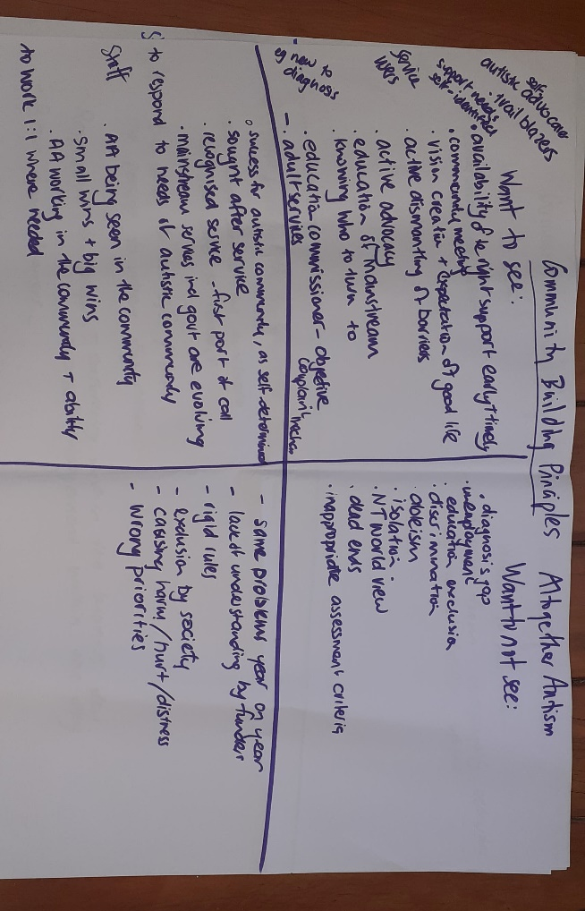
Appendix 2: Workshop activity- identifying EGL practice

Altogether Autism

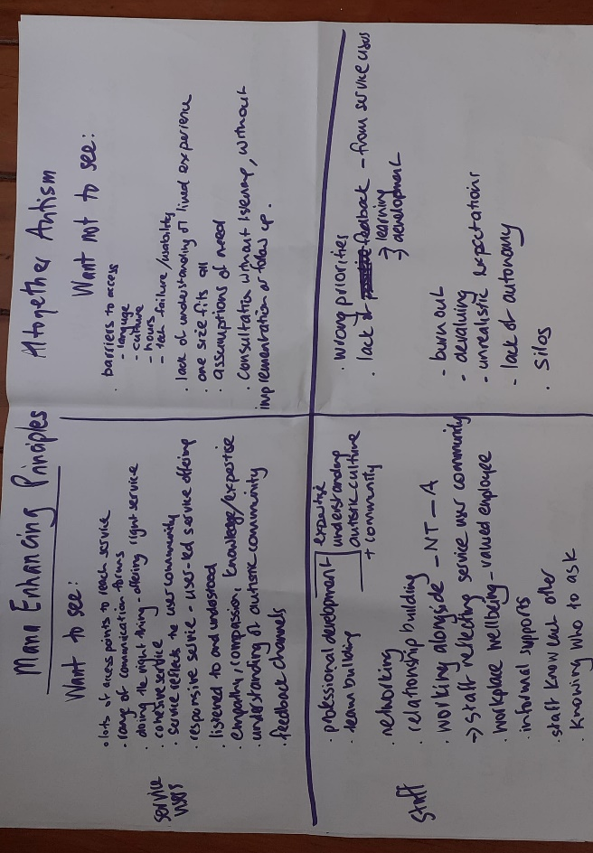

Hearing Therapy

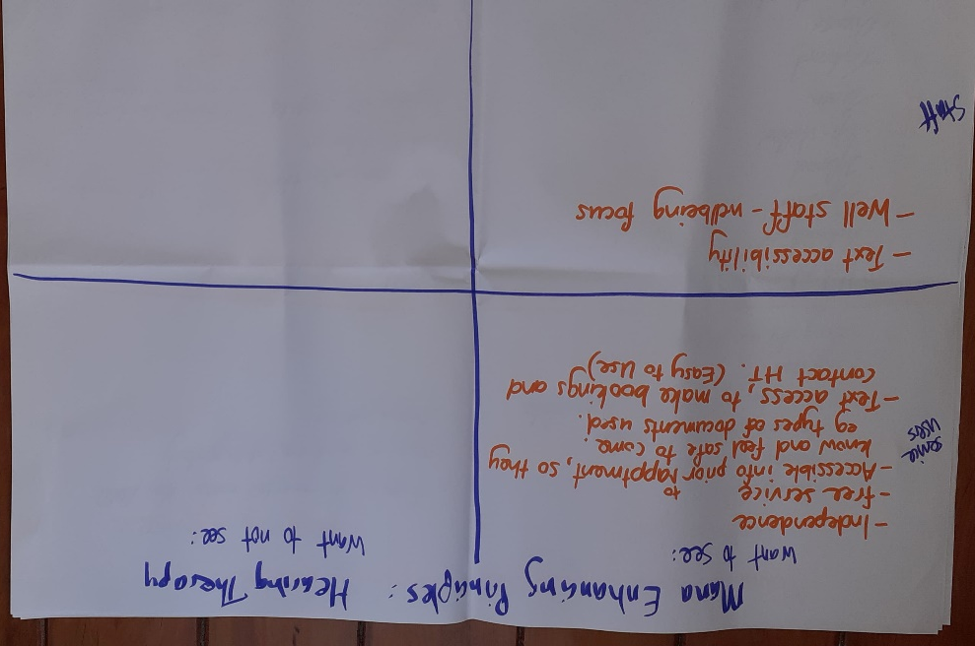

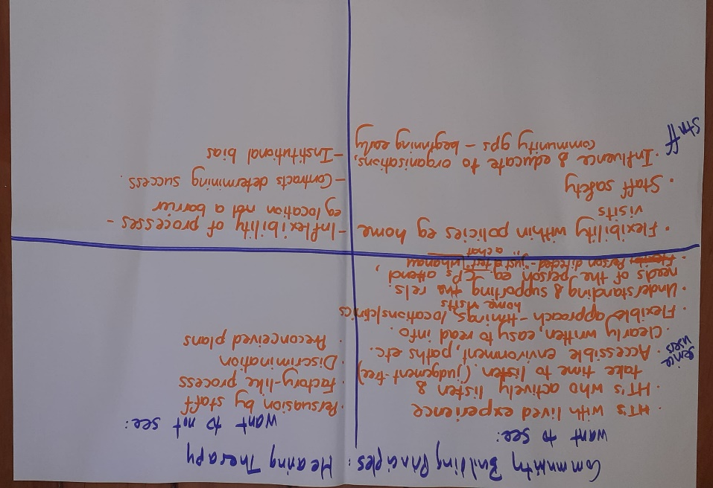

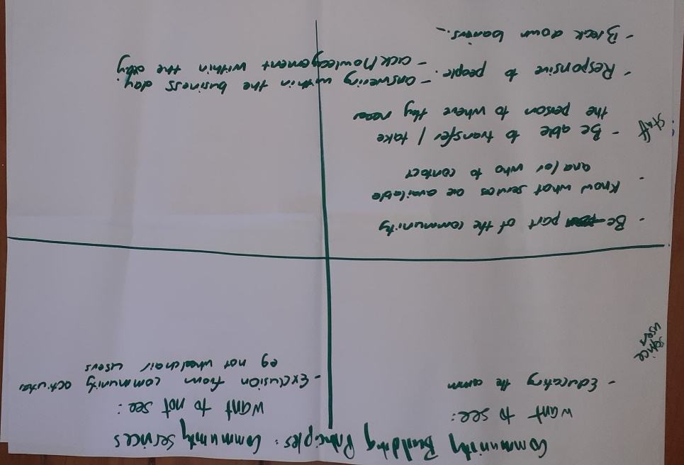
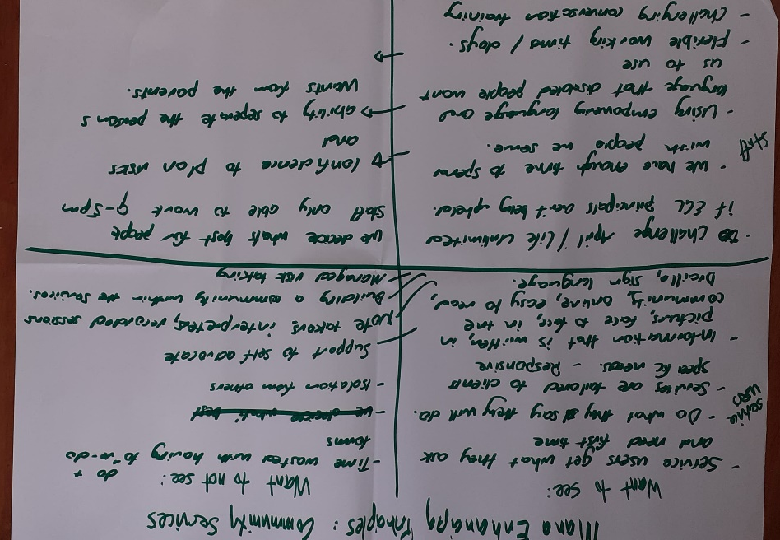
Community
Mobility Centre
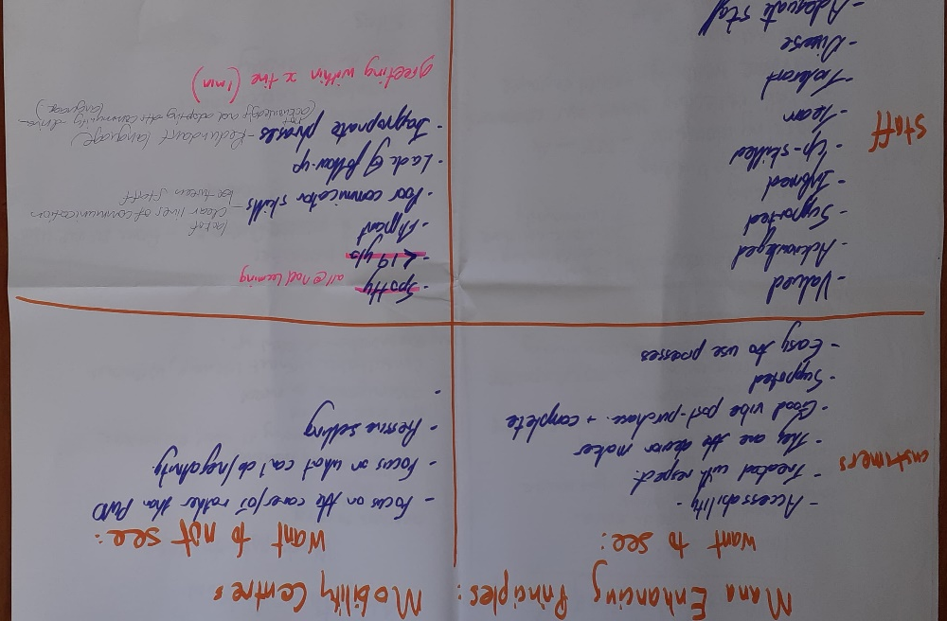
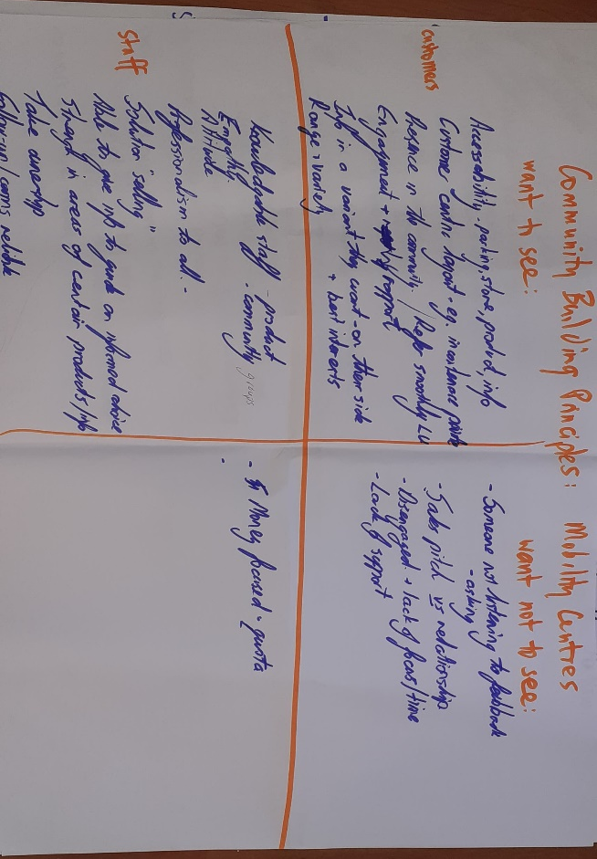

www.enablinggoodlives.co.nz/about-egl/egl-approach/
Imagine Better is an independent disability research, training, and advocacy organisation, governed and staffed by disabled people and close family members of disabled people. See www.imaginebetter.co.nz.
See Appendix 1: EGL Indicators
https://www.dpa.org.nz/
See Appendix 2: Workshop activity- identifying EGL practice

